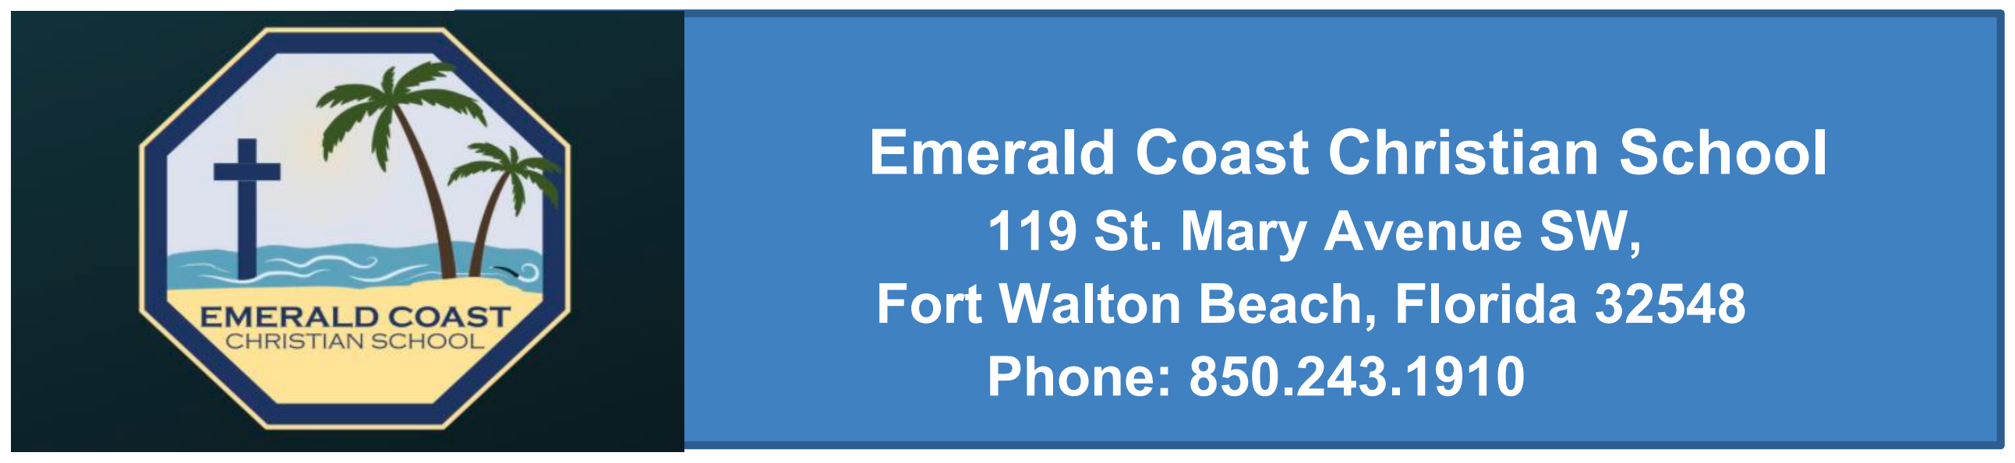

Media Release Consent Form
Please be advised that your child may be photographed or videotaped at various school or conference-sponsored events. Your child’s likeness might appear on the school website, conference website, or other school- related publications. Please sign and return this form.

Please sign and return this form:
___________ Yes, I recognize that school activities are often photographed and./or videotaped. I hereby give consent for the use of any photographs or videotapes of my son/daughter to be used in any school publications or for promotional activities. Forms of publications may include yearbooks, newspapers, newsletters, brochures, school website, and so forth.
___________ No, my child’s photograph and/or video may be used in any school or conference related publications.

Student’s Full Name
__________________________________________ ________________________
Parent/Guardian Signature Date

